**Project 1**

Cristian Heredia

995.110.694

Physics 250 Econophysics, Winter 2013

1. Download data from yahoo finance.

2. Write a code that will compute and plot (vs. time) the 3 month and 12 month returns for a given stock, stock index, ETF, or Mutual Fund. Test it on the S&P 500 (SPX) index going back to 1960. Note that for Yahoo finance, the SPX is designated as ^GSPC.

HD:Users:cristian:Desktop:Econophysics:Project 1:Project1_Returns.pdf

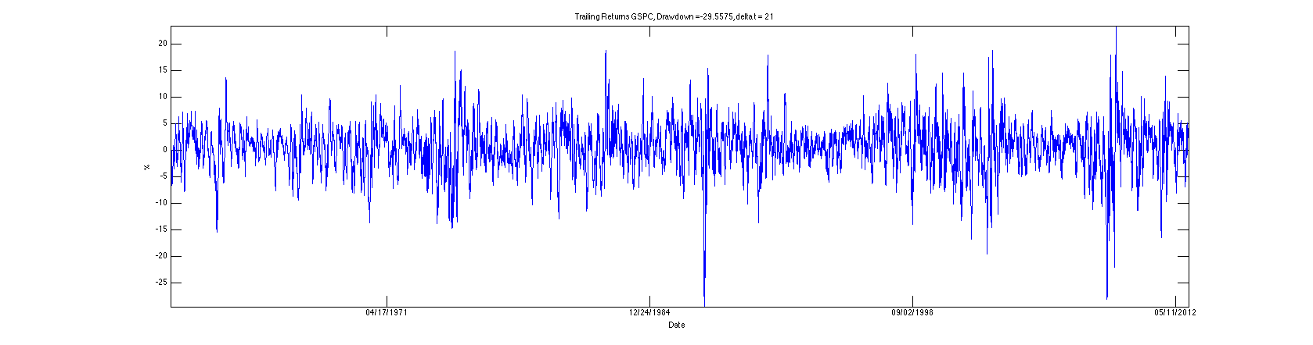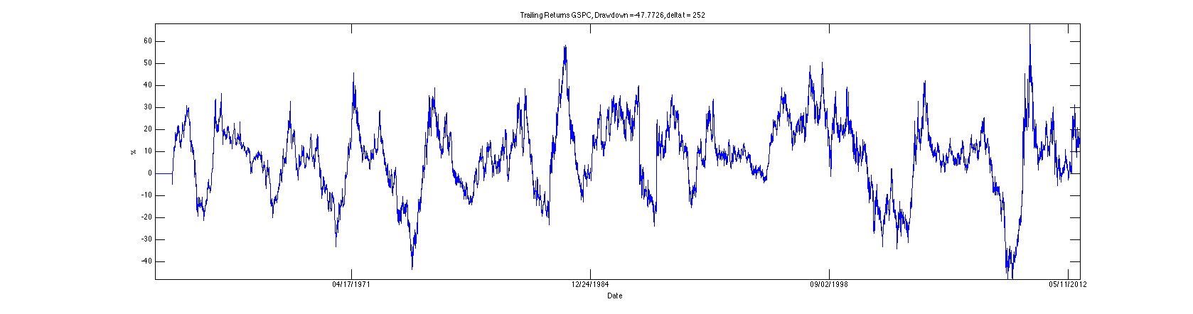

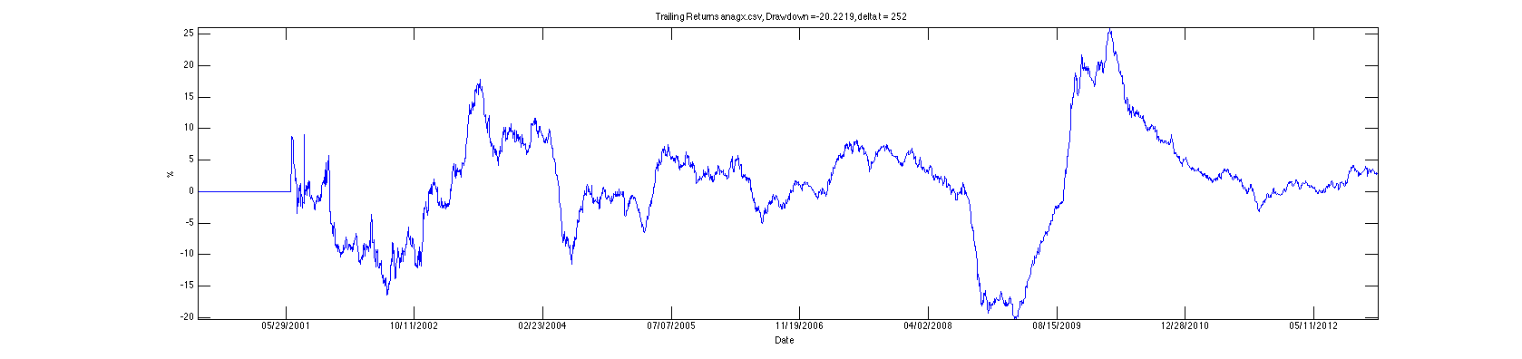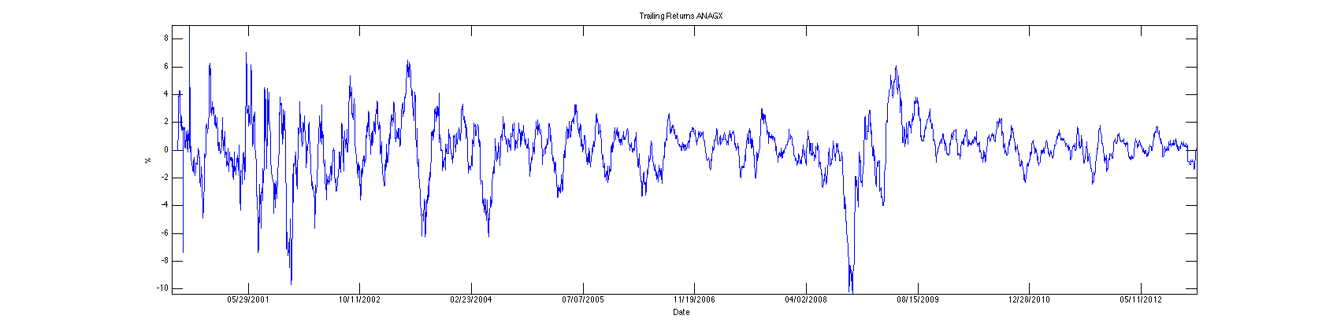

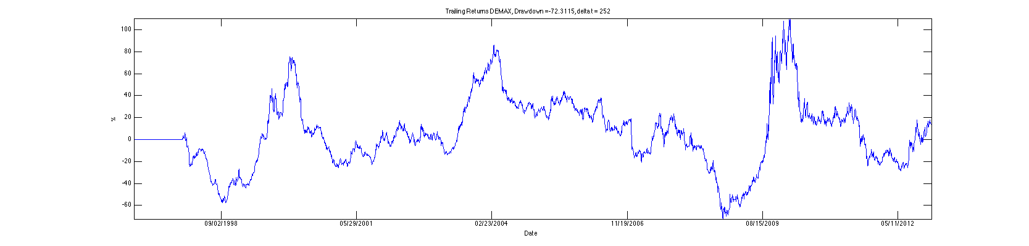

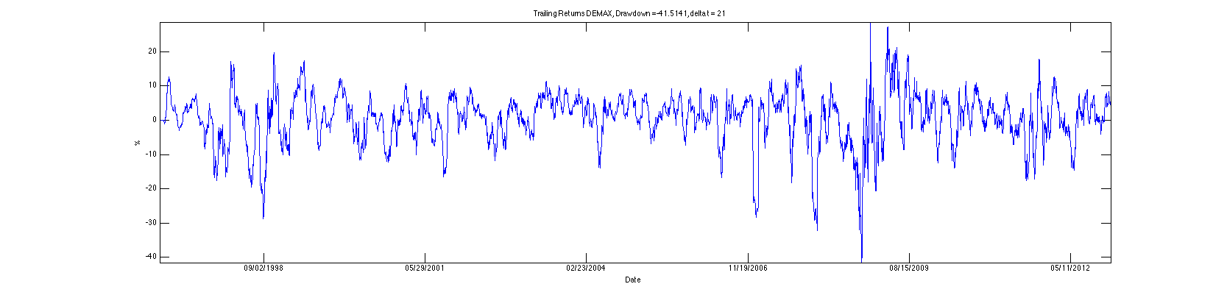

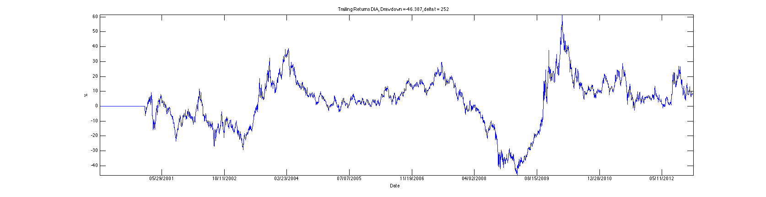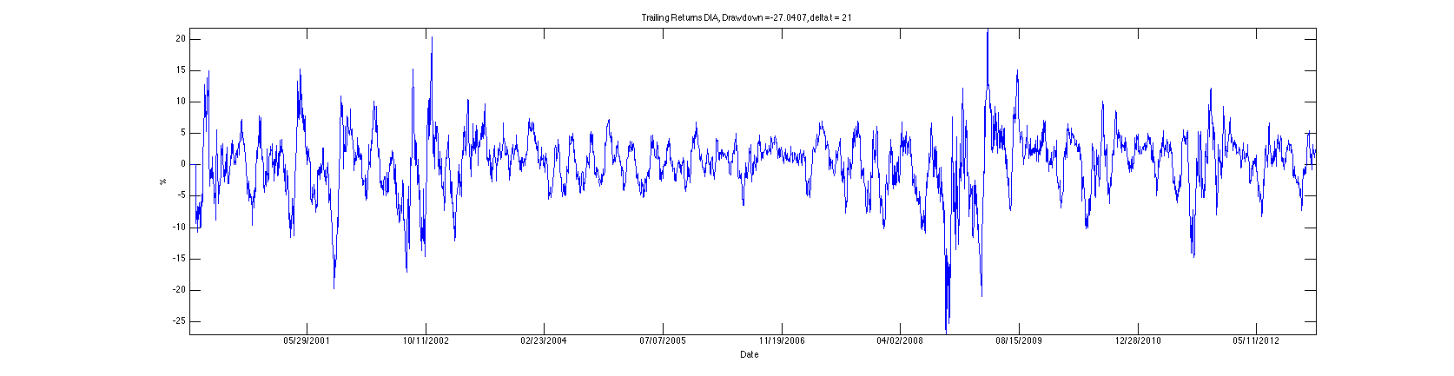

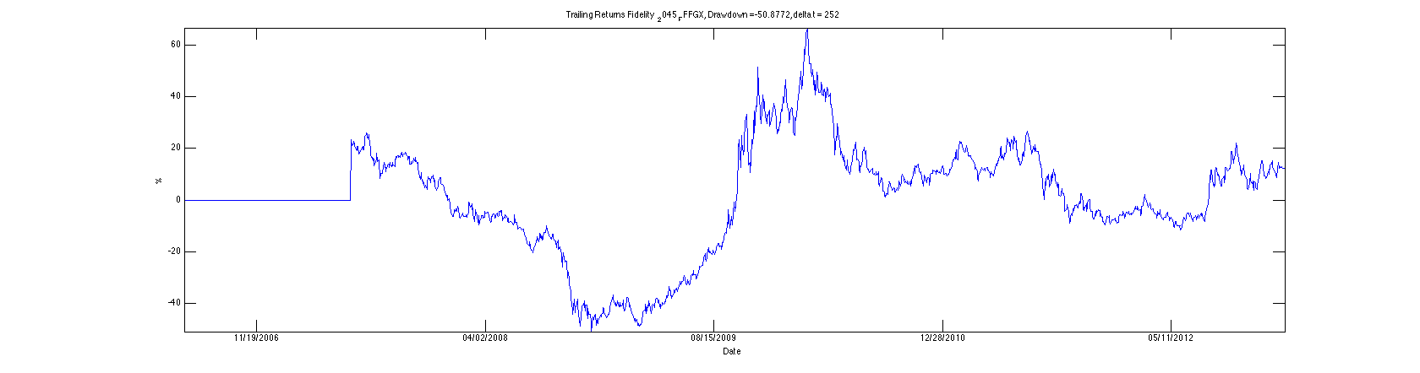

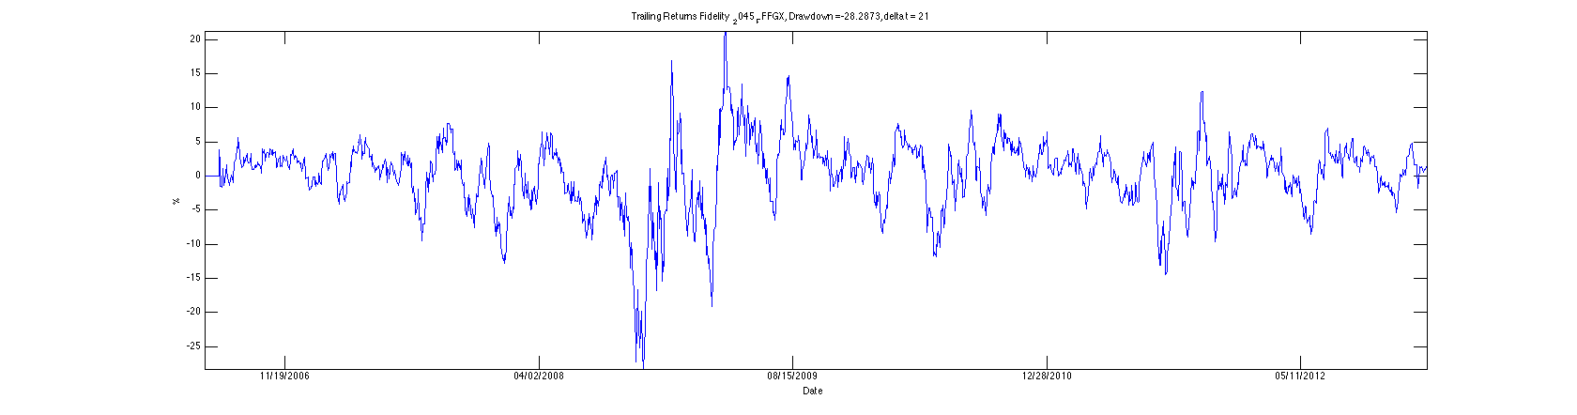

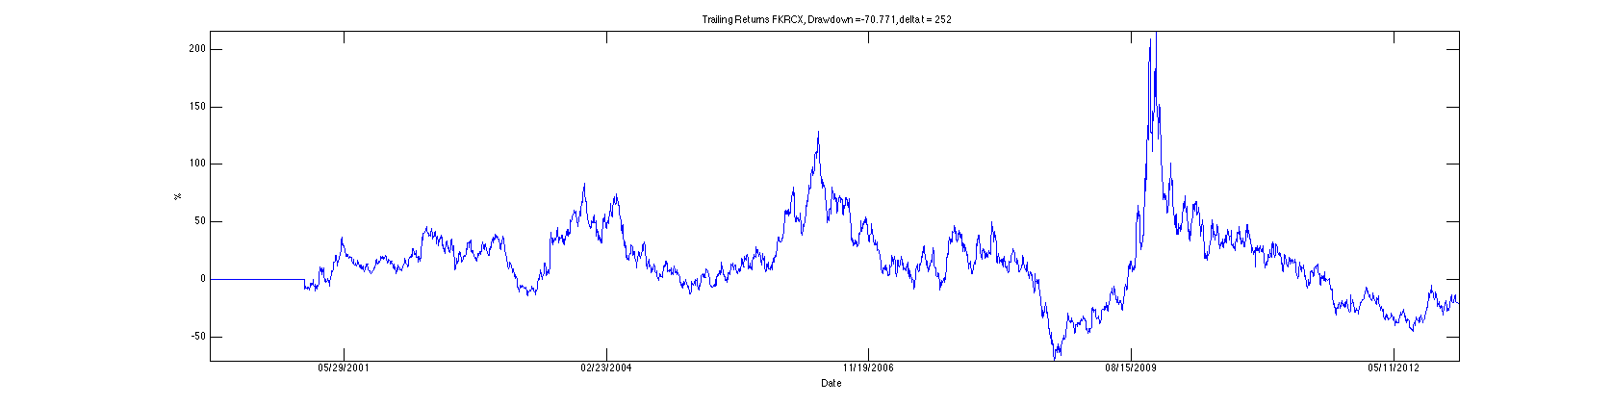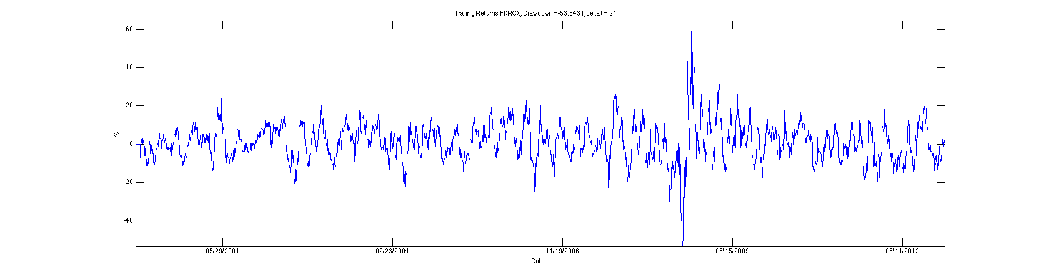

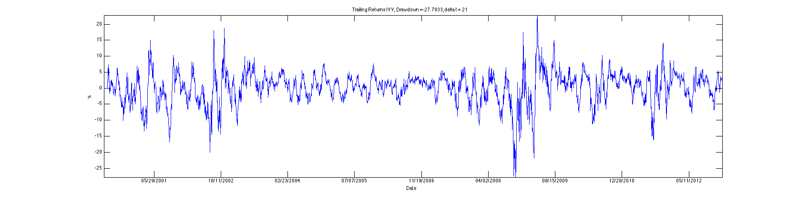

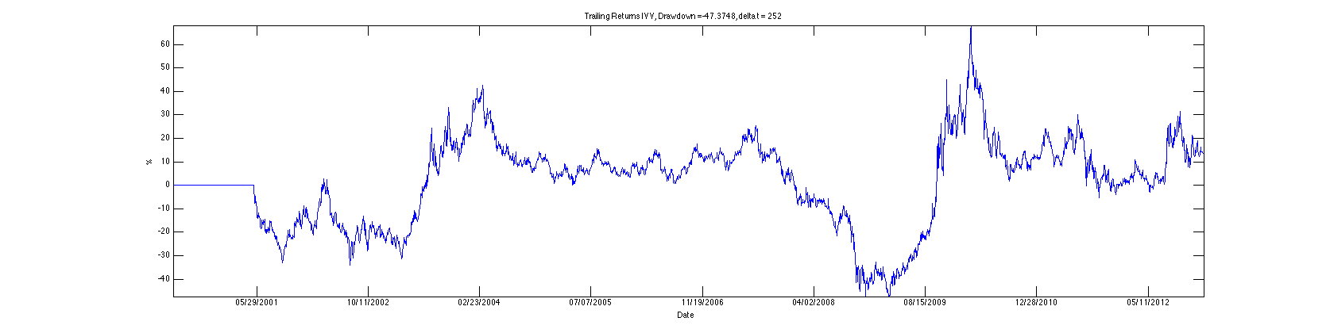

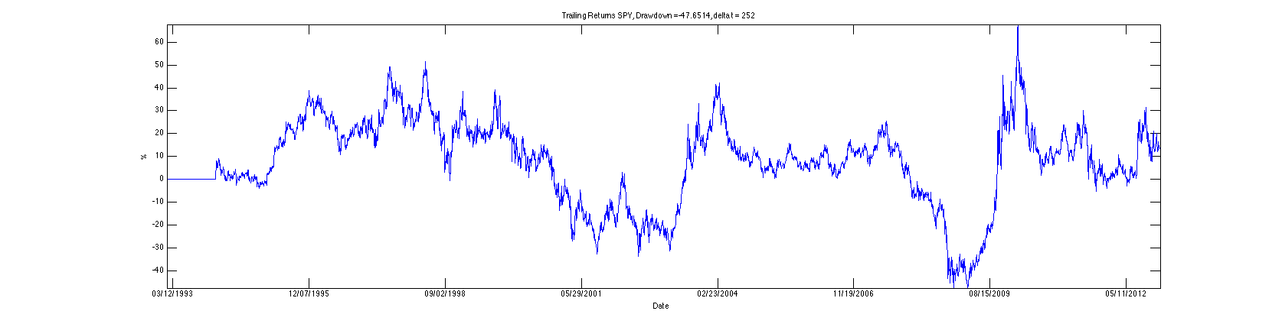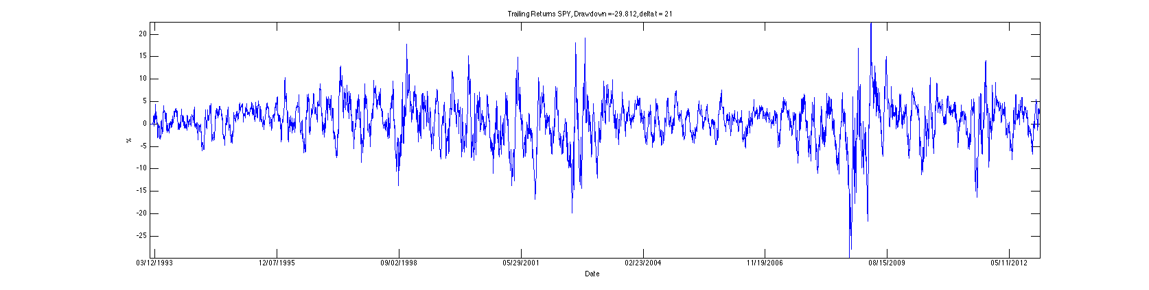

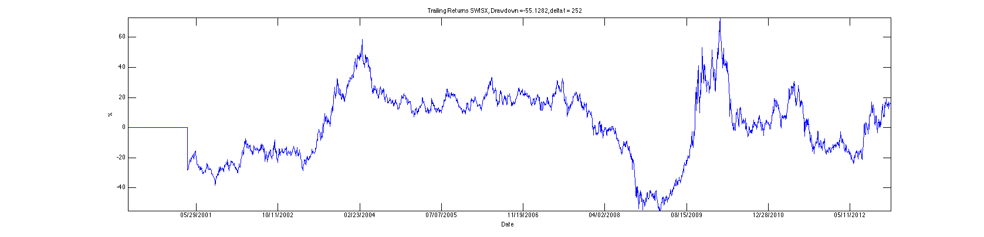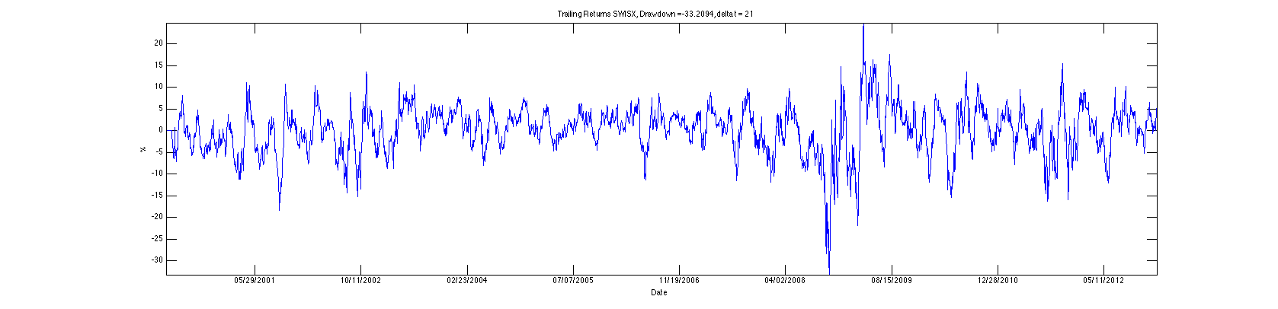

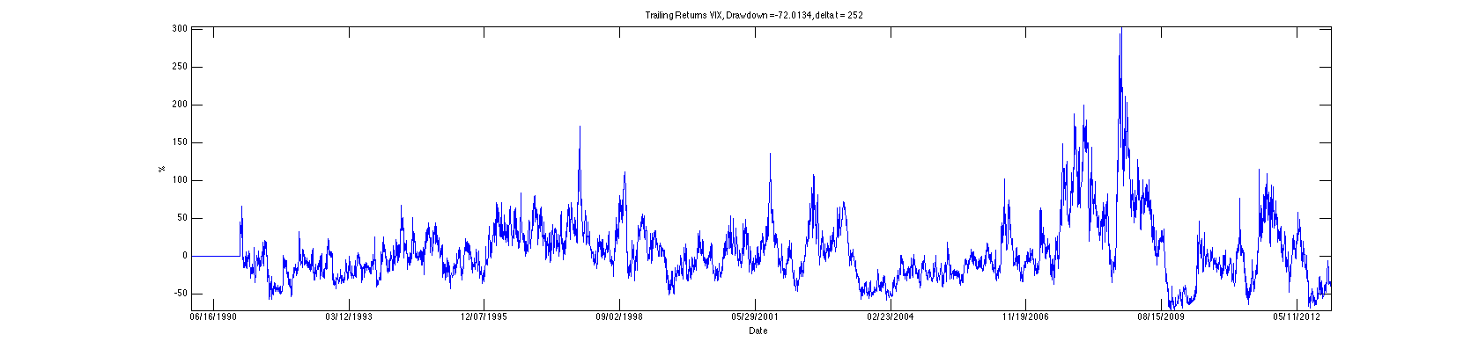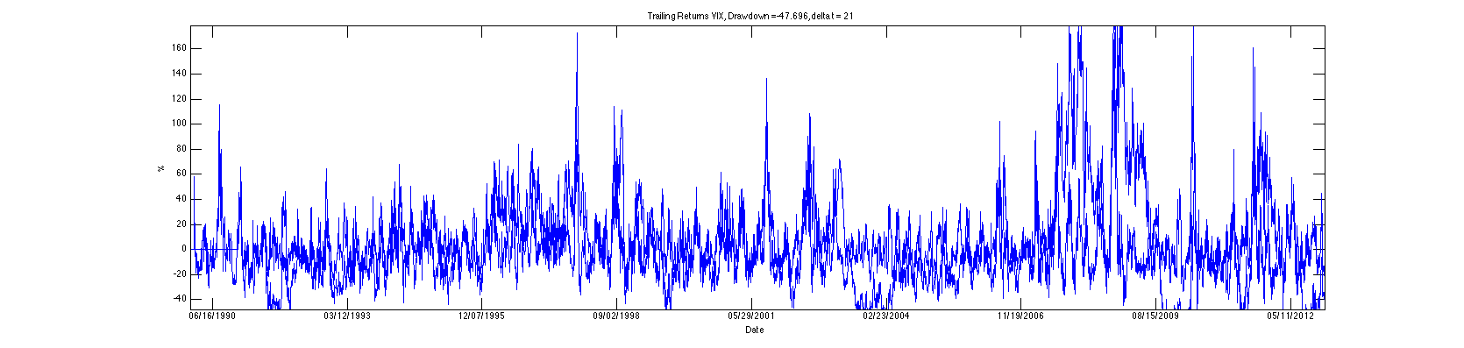

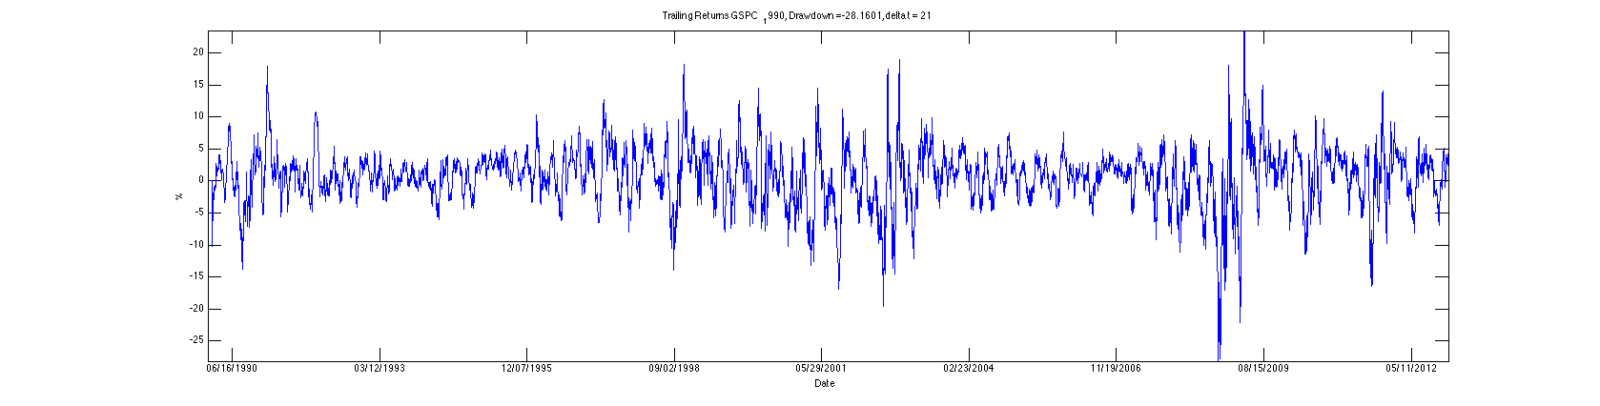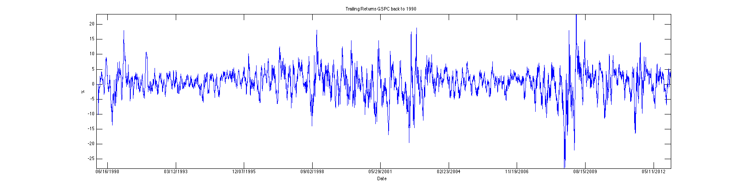

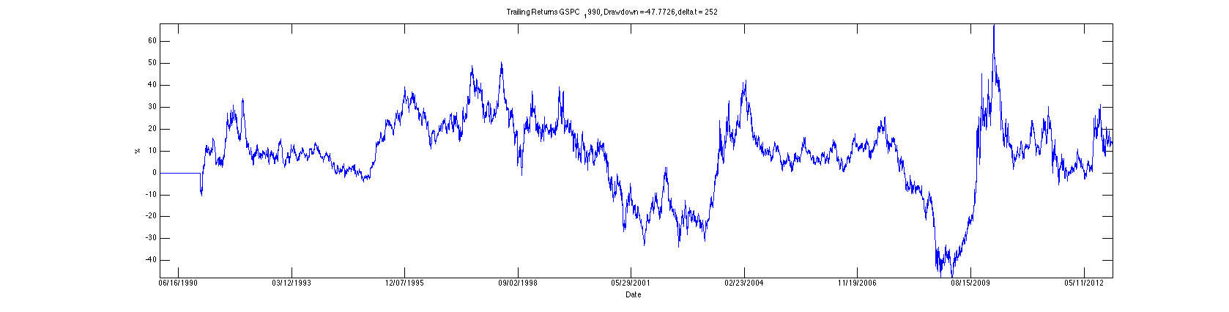



5. What do you notice when you compare the SPX plot with the VIX plot?

Spikes in the VIX are correlated with dips in the SPX